Project Problem Statement

**" Implementation of Data Structures in Developing a Management System for a Medical Store "**

Introduction

“Data structures in a medical store”

The world today is full of sickness, diseases and ailments. Hospitals and medical stores have hence become an indispensable part of our daily life. They literally serve as the lifelines of our society. Serving and tending to all our needs to keep us healthy and safe, a medical store is not only important but extremely vital in our life.

Our software aims to provide the best way to manage a medical store with the least effort. Cataloguing and maintaining a record of almost everything right from the medicines available to the patients we hope to reduce the effort involved in supplying medicines to meet the needs of the public.

SIGNIFICANCE

The significance of our project is governed by the simple fact that never again would human error be either cause of a delay in supply or for providing the wrong drug. Our software is not only aiming to remove these flaws but also to serve as an example towards efficient management and handling of a store in general.

Salient features of our software are:

* Selective accessibility depending on the rank of the user
* Exact data of medicines in stock
* Knowledge about the specific location of each and every medicine
* Report regarding the sale of medicine each day
* Maintaining a log of the details of the sale made (patient name, doctor name etc)
* Log of all salesmen and their transaction details

Implementation of Data Structure

The use of data structures forms the back bone of our project. To illustrate our point here are a few examples which clearly show the use and implementation of Data Structures…

* **Creation** and **deletion** of an user
* **Addition** of medicines to the existing stock
* **Sorting** of medicines according to their expiration dates
* **Merging** of users to update various list
* **Updating** the existing medicines stock
* **Searching** for a specific medicine
* **Locating** the exact shelf of a given medicine
* **Selective accessibility** depending on the type of user

**Keeping a record** of sales and constantly **updating the list**

Progress Report

PLANNIG OF MENU ITEMS & THEIR OPERATIONS

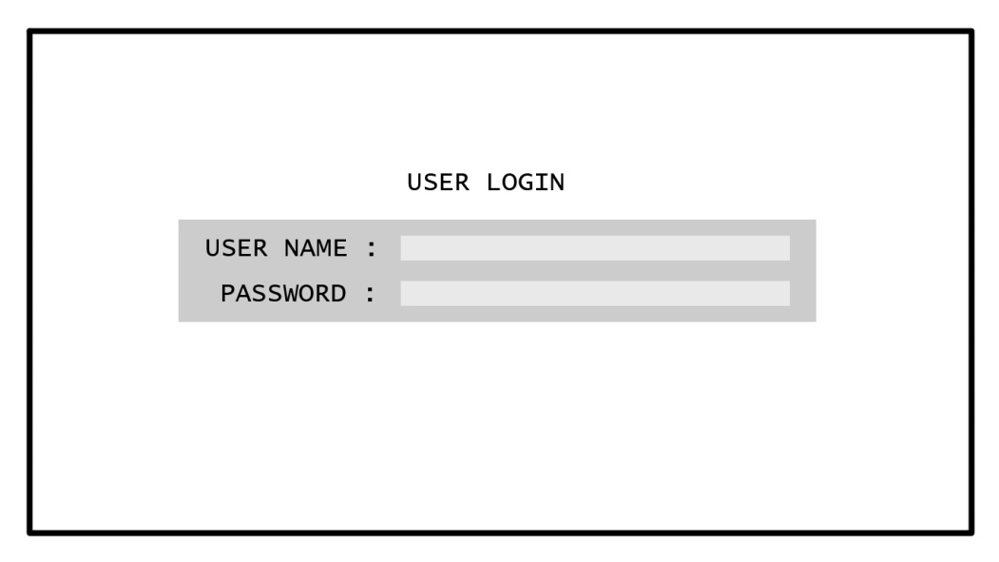

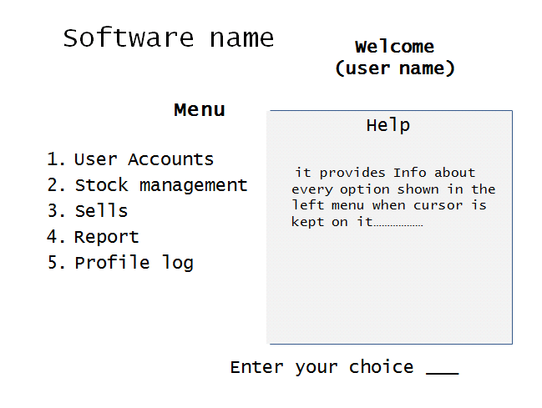

1. Reports

There are various types of reports in our software. Here is a list of all reports our software keeps and their task.

* Medical Stock Report which includes the following…
* Stock of medicines: As the name suggests it keeps a track of all medicines available in the store.
* Medicines nearing expiration.
* Sale of medicines: This is a 3 fold report wherein the record is generated regarding the sale of medicine 1)for the day 2) last 10 days 3) total sales till date

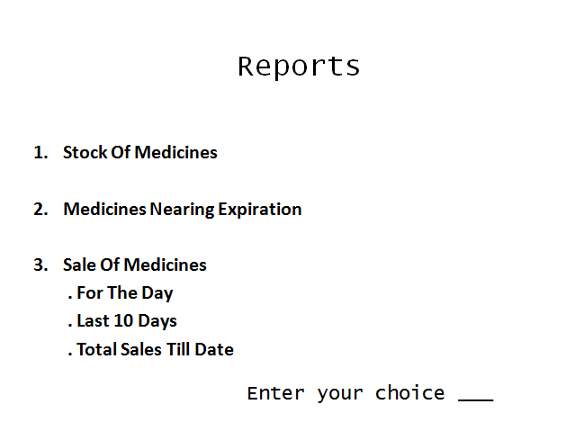

1. Stock Management

The management of a medical store is not easy hence a special provision has been included in our software solely for this purpose.

* Addition of new stock: To keep the store well equipped new medicines will have to be added all the time. At the time of addition this program will prompt the user for the following info

1) Medicine specifications

2) Location of the medicine

* Searching a medicine: To help the user locate a medicine the program will give the following info
* Availability
* Location
* Medical Stock Report: (explained earlier)

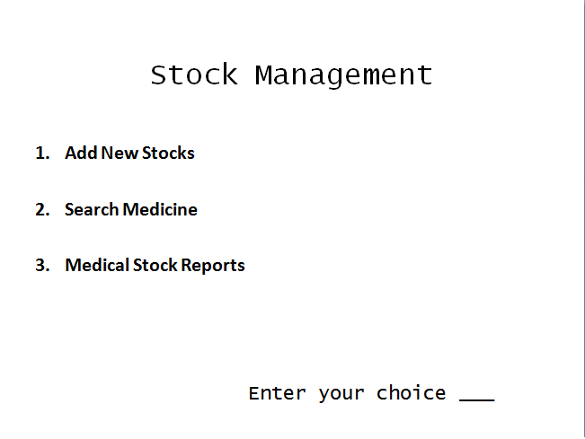

1. Sales Department

A dedicated sales department will allow a better and more efficient working of our store thereby avoiding human errors.

* Sell: This program is the main engine which directs the sale of a particular medicine. But not before it has looked into the requirement and the medicine specifications which has been prescribed by the doctor. This program executes its task in 3 steps…
* Patient name
* Doctor name
* Search and subsequent sale of medicine (as prescribed)

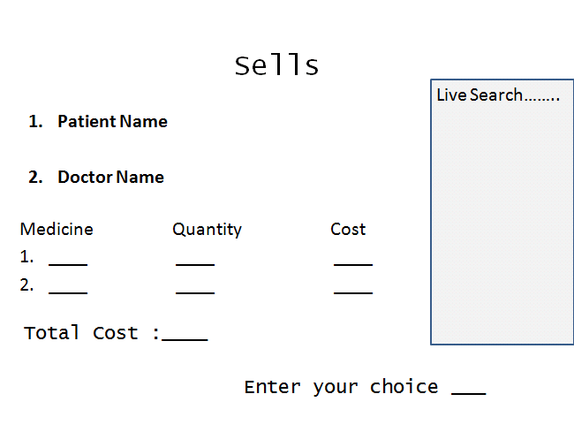

1. Profile Log

Maintains the record of two major segments namely:

* Personal Account
* Personal information (name, address etc)
* Transaction records
* List of users (accessible by the Admin only)

Contains the Personal Account

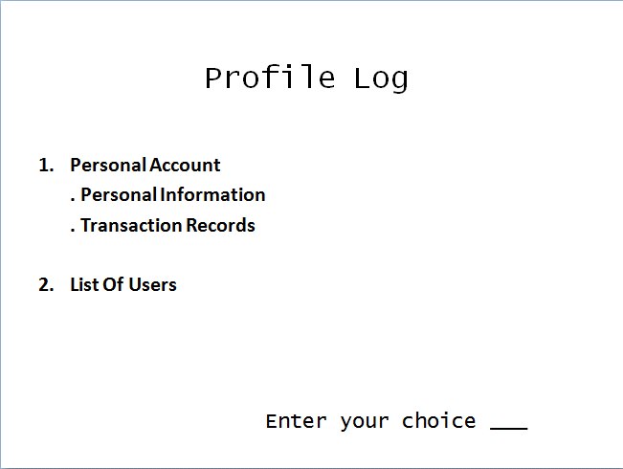

LIST OF USERS

* Administrator: The head of the store who is responsible for the overall management and working of the medical store. The admin has access to all departments/accounts and reports being maintained and can update the lists as required.

The admin has the access to a special menu item called USER ACCOUNTS which enables him to:

* Add, delete or create new users.
* Update list of existing users.
* Look into the profile log of any/all users.
* Management: Looks after the managerial aspects of the store namely:
* Stock of medicines and all that is related
* Sales records

The management has access to the Sales Department as well.

* Sales Department: Solely responsible for looking after the sale of medicines and keeping a record of the same.

